**EXP-18 To write a procedure to run the virtual machine of different configuration and to check how many virtual machines can be utilized at a particular time.**

**AIM:**

To write a procedure to run the virtual machine of different configuration and to check how many virtual machines can be utilized at a particular time.

**PROCEDURE:**

**STEP 1:**

First install VMware workstation in your pc/laptop. Then open the VM software and click create a new virtual machine displayed on a home tab.

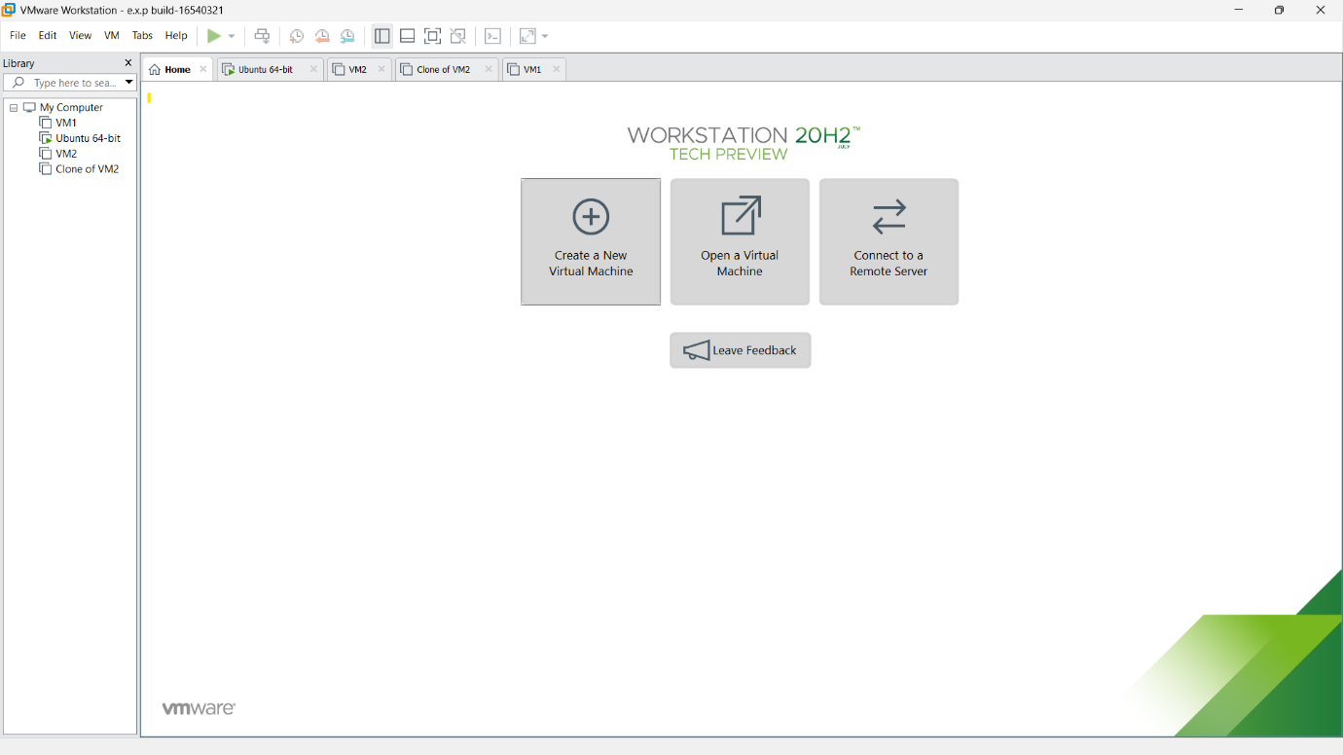

**STEP 2:**

Then below shown message will be displayed and click next.

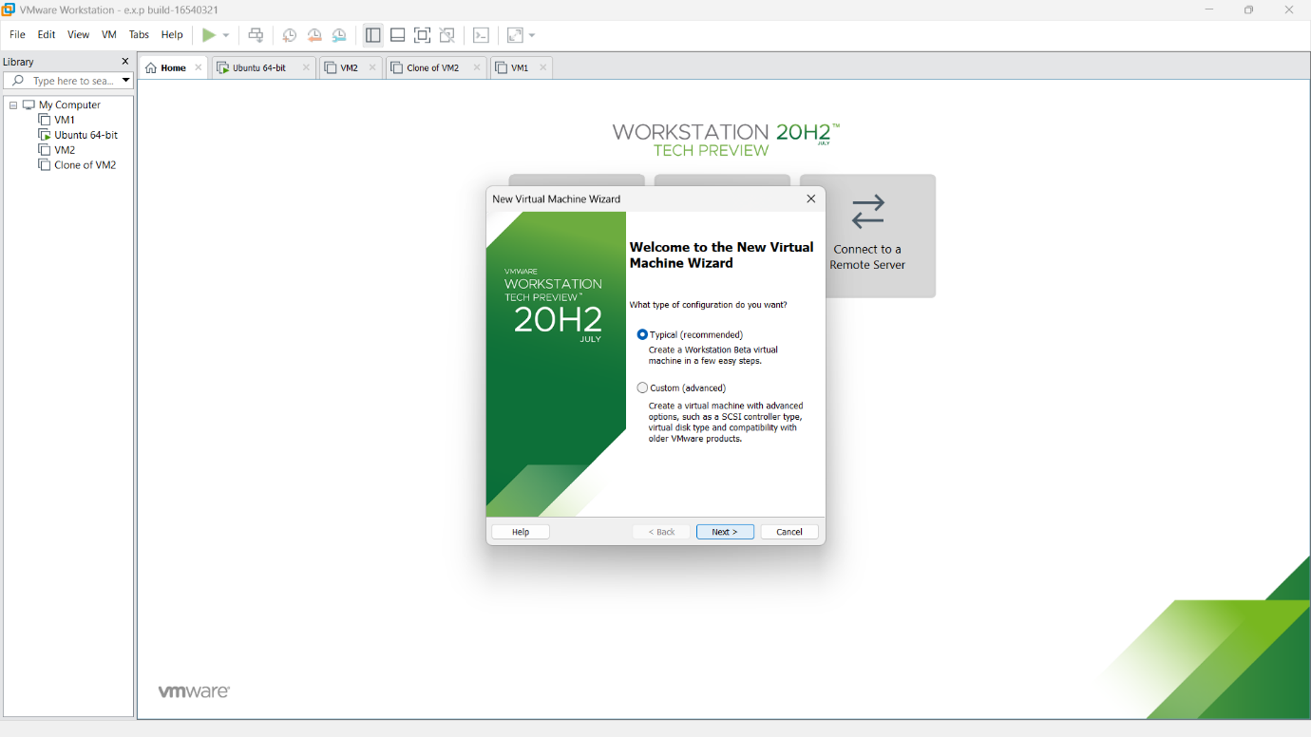

**STEP 3:**

Here,we are going to Create a Virtual Machine with 1 CPU, 2GB RAM and 15GB storage disk using a Type 2 Virtualization Software. So need of any installer.just click the third option and next.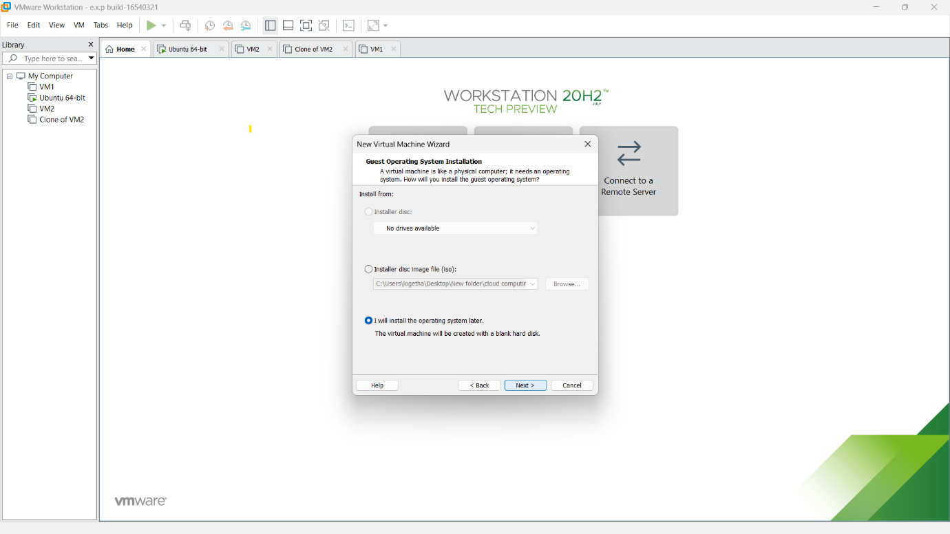

**STEP 4:**

Then select any type of os.

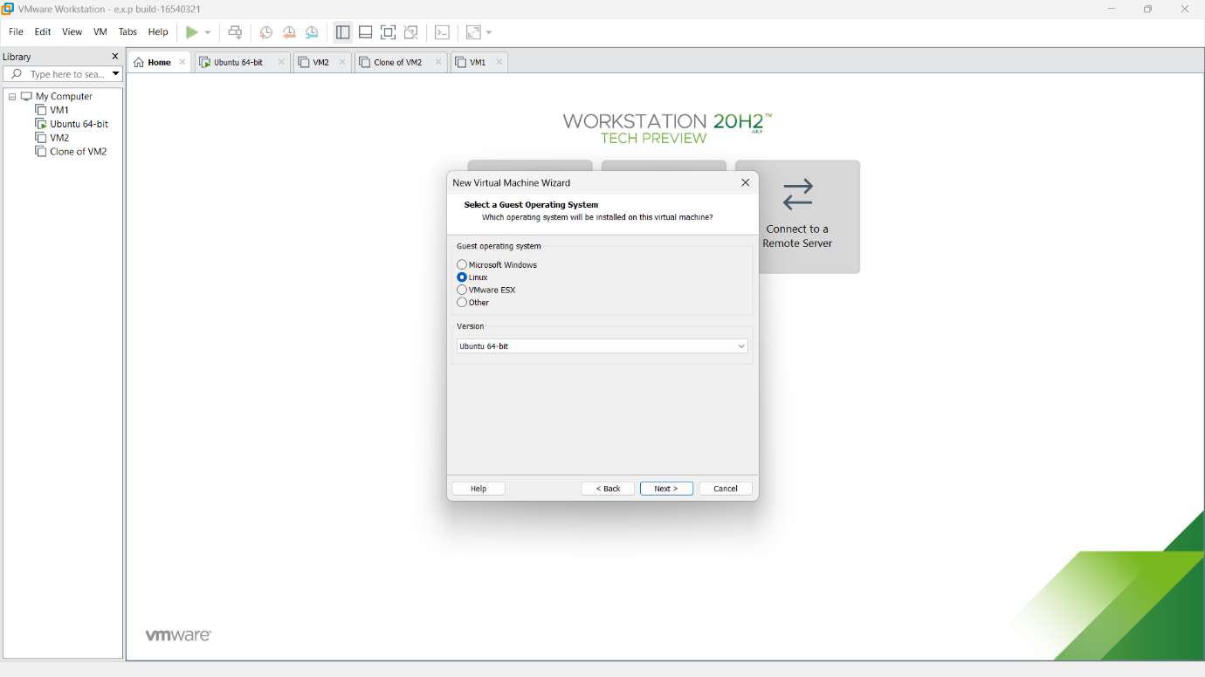

**STEP 5:**

then provide appropriate name for our virtual machine.

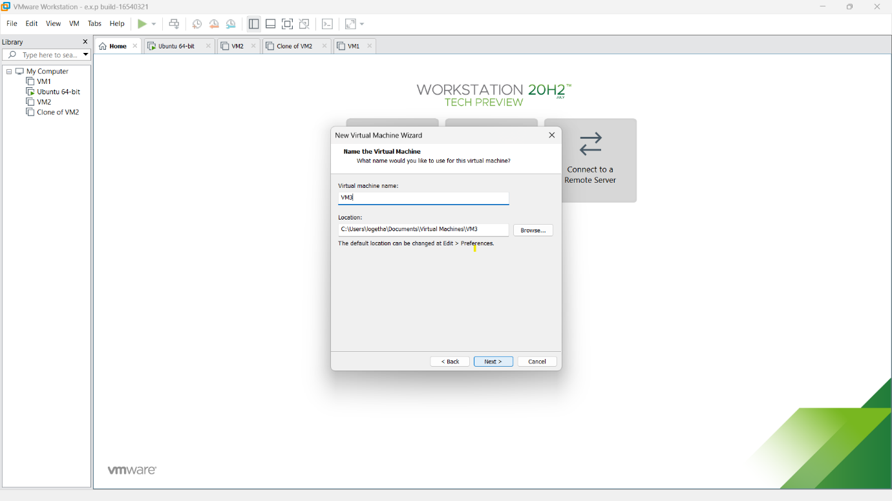

**STEP 6:**

then provide appropriate hard disk size.

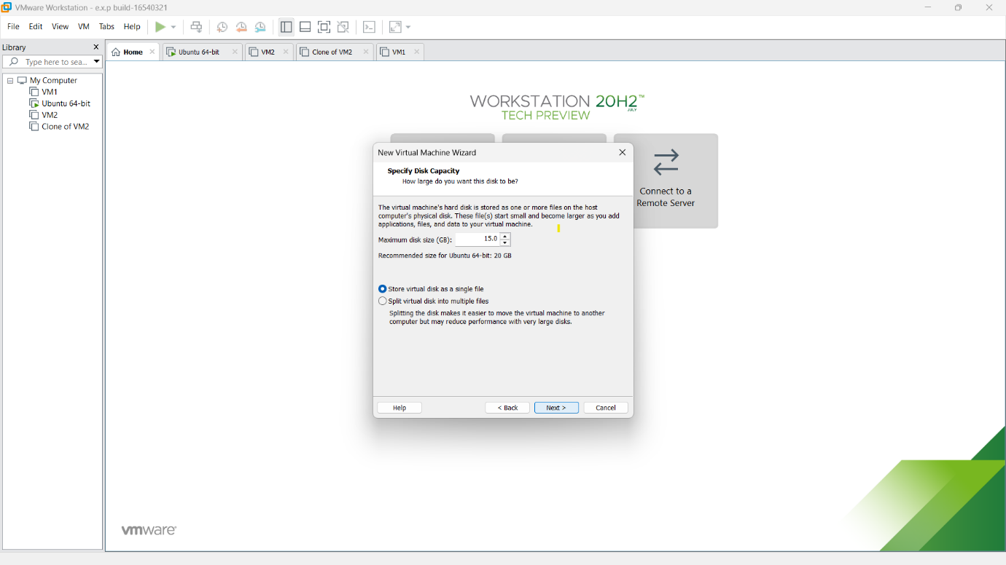

**STEP 7:**

Then verify all the given details are correct and if any changes ,correct it with the customize hardware option.

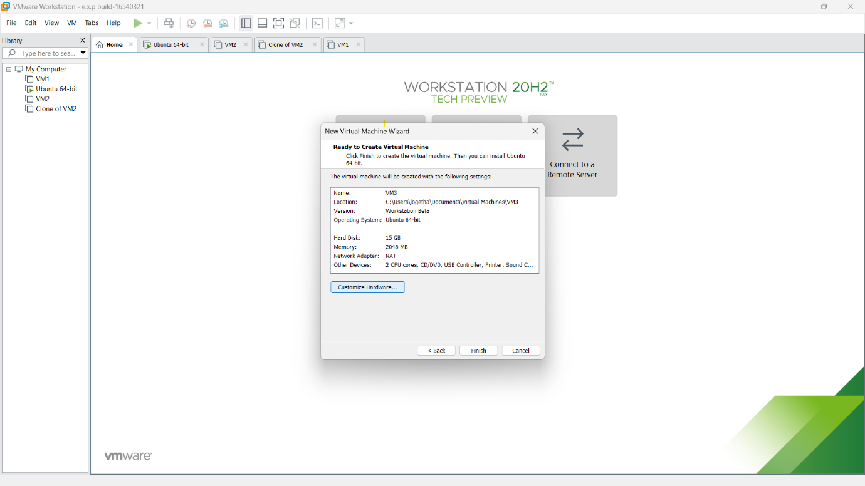

**STEP 8:**

Our VM was created and all the specification were listed left side.